# **Practical – 7**

**Aim:** **Write a program for Automatic grouping of similar objects into sets.**

* Code:

import numpy as np

import pandas as pd

import matplotlib.pyplot as plt

from sklearn.cluster import KMeans

from sklearn.preprocessing import StandardScaler

from sklearn.decomposition import PCA

data_set = pd.read_csv('/content/drive/MyDrive/temp/practical_4_2.csv')

X = data_set[['Match_Duration', 'Loot_Collected', 'Enemies_Defeated']]

scaler = StandardScaler()

X_scaled = scaler.fit_transform(X)

k = 3

kmeans = KMeans(n_clusters=k, random_state=42)

clusters = kmeans.fit_predict(X_scaled)

centroids = kmeans.cluster_centers_

pca = PCA(n_components=2)

X_pca = pca.fit_transform(X_scaled)

centroids_pca = pca.transform(centroids)

data_set['Cluster'] = clusters

colors = ['red', 'green', 'blue']

labels = [f'Cluster {i}' for i in range(k)]

plt.figure(figsize=(10, 7))

for i in range(k):

plt.scatter(X_pca[clusters == i, 0], X_pca[clusters == i, 1],

c=colors[i], label=labels[i])

plt.scatter(centroids_pca[:, 0], centroids_pca[:, 1],

s=200, c='yellow', marker='X', label='Centroids')

new_point = np.array([[26, 77, 15]])

new_point_scaled = scaler.transform(new_point)

new_point_cluster = kmeans.predict(new_point_scaled)[0]

new_point_pca = pca.transform(new_point_scaled)

plt.scatter(new_point_pca[0, 0], new_point_pca[0, 1],

c='black', s=150, marker='*', label=f'Data point {new_point[0]} is in Cluster {new_point_cluster}')

plt.title("K-Means Clustering with PCA (Grouped)")

plt.xlabel("PCA Feature 1")

plt.ylabel("PCA Feature 2")

plt.legend()

plt.grid(True)

plt.tight_layout()

plt.show()

* 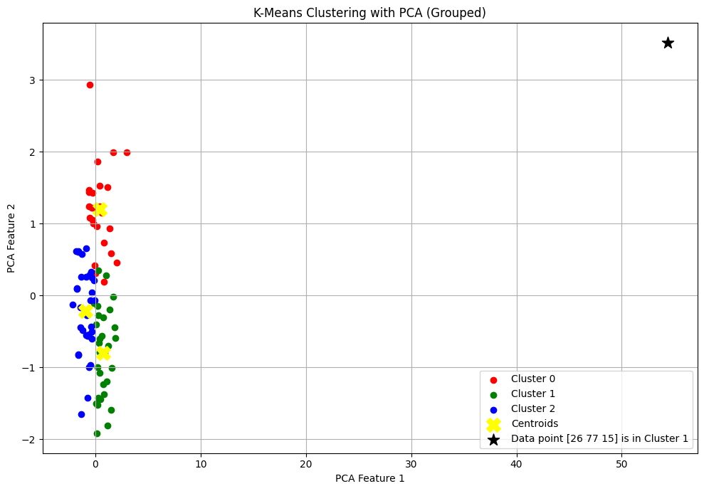Output

Faculty Signature: _______________ Date: _____________________